Chapter 9, Problem 80.

Consider the phase-shifting circuit in Fig. 9.83. Let V_{i} = 120 V operating at 60 Hz. Find:

(a) V_{o} when R is maximum

(b) V_{o} when R is minimum

(c) the value of R that will produce a phase shift of 45° V.

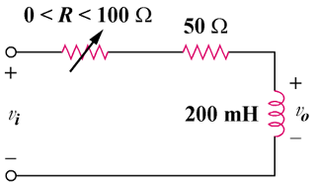

Figure 9.83
For Prob. 9.80.

